Khangai Herds 8- Training for Naadam

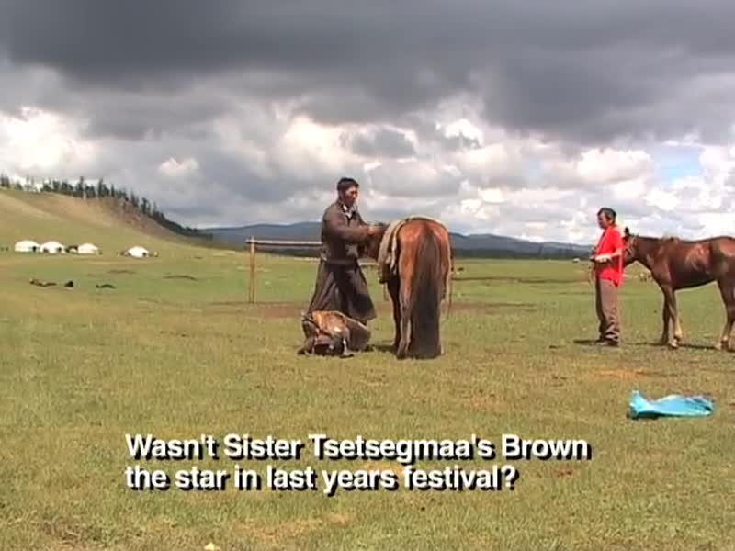

### identifier

b14b6fe6-2e23-480e-aa4d-13349a3de887

### creator

Fijn, Natasha

### type

Moving Image

### coverage

Mongolia

### description

The eighth segment of Khangai Herds features the training of racehorses for the national festival of Mongolia, the Naadam. A feisty two-year-old horse is ridden by the young herder Saikhanaa in preparation for a Naadam attended by local herding families in the Khangai Mountains of Mongolia.

### publisher

### source

<https://vimeo.com/14315685>

### rights

<https://creativecommons.org/licenses/by-nc-nd/3.0/>

### subject

Living with Herds

Naadam

co-domestic

domestication

ethnography

horse

horse training

human-animal

khangai herds

observational film

pastoralism

racehorses

racing

visual

### date

2010-08-21

### language

Mongolian

### format

video/mp4

### contributor

### original filename

Khangai Herds 8- Training for Naadam.mp4

### remote embed url

https://player.vimeo.com/video/14315685

### relation

### extent

63.0MiB

741.435000